
PUNJAB UNIVERSITY COLLEGE OF
INFORMATION TECHNOLOGY
Project Topic:
Tuition Management System
Course Name:
Database System
Submitted to:
DR.ASIF SOHAIL
Submitted By:
Roll No | Name
BITF24M047 | BARIRA BADAR
BITF24M026 | UMM E AMMARA
BITF23M053 | KARIMA

Sr. | Topics
1 | Introduction
2 | ERD OF TUTION MANAGEMENT SYSTEM
3 | RELATIONAL SCHEMA
4 | RELATIONAL MODEL
5 | DESCRIPTION OF THE RELATIONS
6 | TABLES CREATION USING SQL
7 | INSERTION OF DATA IN THE TABLES
8 | VIEWS CREATION USING SQL
9 | SELECT STATEMENTS FOR COMMON REPORTS

Introduction

This tuition management system is a comprehensive software solution designed to streamline financial and administrative processes within an educational tuition center. The system manages center-related information, including center identification (CENTER_ID) and associated details such as center name (CENTER_NAME) and location.

The system maintains a hierarchical structure of centers, courses, and batches through interconnected tables. The system efficiently manages tutor information in the TUTOR table, which includes tutor identification (TUTOR_ID), name, contact details, qualifications, and joining date. Each tutor is assigned to specific courses they are qualified to teach.

For student management, the system incorporates the STUDENT, GUARDIAN, and ENROLLMENT tables. The STUDENT table records essential student information, including student identification (STD_ID), names, date of birth, contact information, and emergency contacts. The GUARDIAN table stores guardian details linked to each student. The ENROLLMENT table tracks student course enrollments, enrollment dates, and status.

The system comprehensively manages financial aspects, including FEE_STRUCTURE, and PAYMENT tables. The FEE_STRUCTURE table defines course fees, payment schedules, and due dates. The PAYMENT table records all financial transactions, including payment dates, amounts, payment methods, and transaction IDs. The DISCOUNT table manages scholarship and discount information for eligible students.

Batch management is handled through the BATCH and BATCH_SCHEDULE tables. The BATCH table defines batch codes, capacities, and assigned tutors, while the BATCH_SCHEDULE table manages class timings, days, and room allocations.

The system also includes COURSE_MATERIAL and ATTENDANCE modules. The COURSE_MATERIAL table tracks study materials distributed to students, while the ATTENDANCE table monitors student attendance for each batch session.

This integrated system provides a robust framework for managing all aspects of a tuition center, including student enrollment, tutoring assignments, financial management, scheduling, and academic tracking.

The system effectively handles course-related information through the COURSE and COURSE_PREREQUISITE tables. The COURSE table contains course details including course codes (COURSE_CODE), names, duration, difficulty levels, and descriptions. The relationship between courses, such as prerequisites, is maintained in the COURSE_PREREQUISITE table, which identifies required prior courses.

Financial reporting and analytics are enabled through the PAYMENT_HISTORY and FEE_REMINDER tables. The PAYMENT_HISTORY maintains a complete audit trail of all financial transactions, while FEE_REMINDER automates payment notifications for overdue fees.

The PERFORMANCE table tracks student academic progress through regular assessments, quizzes, and final exams, providing tutors and administrators with comprehensive academic monitoring capabilities.

This tuition management system integrates all key components needed for managing center operations, tutors, students, courses, batches, and financial transactions, providing a complete solution for efficient tuition center administration and improved service delivery to students and parents.

ERD OF THE TUTION MANAGEMENT SYSTEM

ENTITY | Relationship | Connectivity | Entity
STUDENT | ENROLLS | M:M | COURSES
STUDENT | HAS | 1:1 | GUARDIAN
TUTOR | TEACHES | M:M | BATCHES
STUDENT | ATTENDS | M:M | BATCHES
BATCH | HAS | 1:M | BATCH_SCHEDULE
CENTER | HAS | 1:M | BATCHES
COURSE | HAS | 1:M | FEE_STRUCTURE
STUDENT | PAYS | 1:M | PAYMENT
PAYMENT | HAS | 1:M | PAYMENT_HISTORY
STUDENT | RECEIVES | 1:M | DISCOUNT
COURSE | REQUIRES | M:M | PRE_REQUISITE
TUTOR | CREATES | 1:M | COURSE_MATERIAL
STUDENT | HAS | 1:M | PERFORMANCE

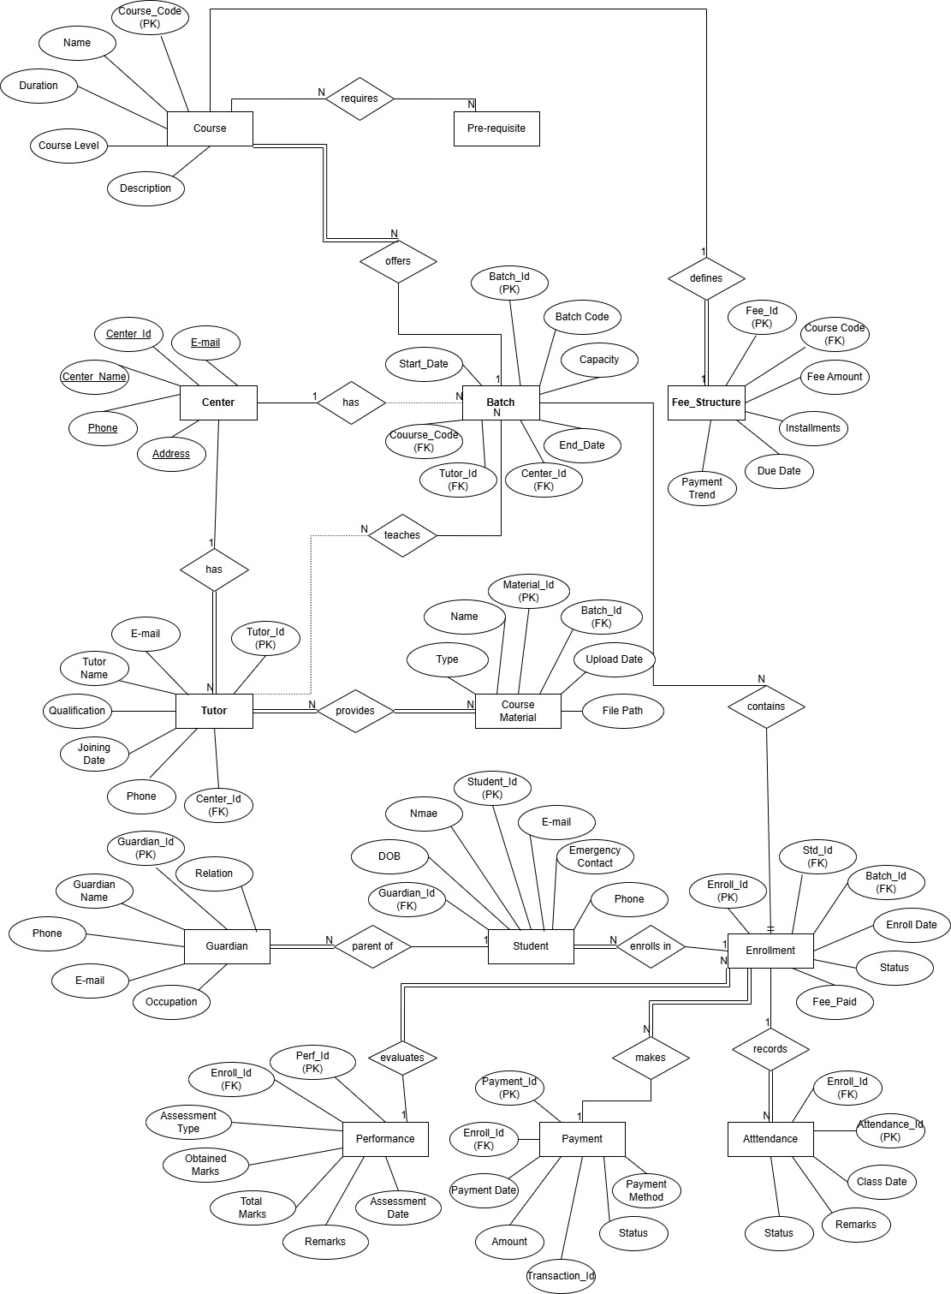

RELATIONAL SCHEMA

- CENTER (CENTER_ID, CENTER_NAME, ADDRESS, PHONE, EMAIL)
Attributes:
- CENTER_ID: Unique identifier for each center (Primary Key).
- CENTER_NAME: The name of the tuition center.
- ADDRESS: Physical address of the center.
- PHONE: Contact phone number.
- EMAIL: Contact email address.

Primary Key (PK): CENTER_ID

- TUTOR (TUTOR_ID, TUTOR_NAME, QUALIFICATION, PHONE, EMAIL, JOINING_DATE, CENTER_ID)
Attributes:
- TUTOR_ID: Unique identifier for each tutor (Primary Key).
- TUTOR_NAME: Full name of the tutor.
- QUALIFICATION: Educational qualifications.
- PHONE: Contact phone number.
- EMAIL: Email address.
- JOINING_DATE: Date when tutor joined.
- CENTER_ID: References the center where the tutor works (Foreign Key).

Primary Key (PK): TUTOR_ID
Foreign Key (FK): CENTER_ID references CENTER(CENTER_ID)

- GUARDIAN (GUARDIAN_ID, GUARDIAN_NAME, RELATION, PHONE, EMAIL, OCCUPATION)
Attributes:
- GUARDIAN_ID: Unique identifier for each guardian (Primary Key).
- GUARDIAN_NAME: Full name of the guardian.

- RELATION: Relationship with student (Father/Mother/Other).
- PHONE: Contact phone number.
- EMAIL: Email address.
- OCCUPATION: Occupation of guardian.

Primary Key (PK): GUARDIAN_ID

- STUDENT (STD_ID, STD_NAME, DOB, PHONE, EMAIL, EMERGENCY_CONTACT, GUARDIAN_ID)
Attributes:
- STD_ID: Unique identifier for each student (Primary Key).
- STD_NAME: Full name of the student.
- DOB: Date of birth of the student.
- PHONE: Contact phone number.
- EMAIL: Email address.
- EMERGENCY_CONTACT: Emergency contact number.
- GUARDIAN_ID: References the student's guardian (Foreign Key).

Primary Key (PK): STD_ID
Foreign Key (FK): GUARDIAN_ID references GUARDIAN(GUARDIAN_ID)

- COURSE (COURSE_CODE, COURSE_NAME, DURATION_MONTHS, LEVEL, DESCRIPTION)
Attributes:
- COURSE_CODE: Unique code for each course (Primary Key).
- COURSE_NAME: Name of the course.
- DURATION_MONTHS: Duration in months.
- LEVEL: Difficulty level (Beginner/Intermediate/Advanced).
- DESCRIPTION: Course description.

Primary Key (PK): COURSE_CODE

- BATCH (BATCH_ID, BATCH_CODE, CAPACITY, START_DATE, END_DATE, COURSE_CODE, TUTOR_ID, CENTER_ID)
Attributes:
- BATCH_ID: Unique identifier for each batch (Primary Key).
- BATCH_CODE: Batch code/name.
- CAPACITY: Maximum students in a batch.
- START_DATE: Batch start date.
- END_DATE: Batch end date.
- COURSE_CODE: References the course taught (Foreign Key).
- TUTOR_ID: References the assigned tutor (Foreign Key).
- CENTER_ID: References the center (Foreign Key).
- COURSE_CODE references COURSE(COURSE_CODE)
- TUTOR_ID references TUTOR(TUTOR_ID)
- CENTER_ID references CENTER(CENTER_ID)

Primary Key (PK): BATCH_ID
Foreign Keys (FKs): COURSE_CODE references COURSE(COURSE_CODE) , TUTOR_ID references TUTOR(TUTOR_ID) , CENTER_ID references CENTER(CENTER_ID)

- ENROLLMENT (ENROLL_ID, STD_ID, BATCH_ID, ENROLL_DATE, STATUS, FEES_PAID)
Attributes:
- ENROLL_ID: Unique identifier for enrollment (Primary Key).
- STD_ID: References the enrolled student (Foreign Key).
- BATCH_ID: References the batch (Foreign Key).
- ENROLL_DATE: Date of enrollment.
- STATUS: Enrollment status (Active/Completed/Dropped).
- FEES_PAID: Total fees paid to date.
- STD_ID references STUDENT(STD_ID)
- BATCH_ID references BATCH(BATCH_ID)

Primary Key (PK): ENROLL_ID
Foreign Keys (FKs): STD_ID references STUDENT(STD_ID) , BATCH_ID references BATCH(BATCH_ID)

- FEE_STRUCTURE (FEE_ID, COURSE_CODE, FEE_AMOUNT, INSTALLMENTS, DUE_DATE, PAYMENT_TERMS)
Attributes:
- FEE_ID: Unique identifier for fee structure (Primary Key).
- COURSE_CODE: References the course (Foreign Key).
- FEE_AMOUNT: Total course fee.
- INSTALLMENTS: Number of installments allowed.
- DUE_DATE: Fee due date.
- PAYMENT_TERMS: Payment terms and conditions.

Primary Key (PK): FEE_ID
Foreign Keys (FKs): COURSE_CODE references COURSE(COURSE_CODE)

- PAYMENT (PAYMENT_ID, ENROLL_ID, PAYMENT_DATE, AMOUNT, PAYMENT_METHOD, TRANSACTION_ID, STATUS)
Attributes:
- PAYMENT_ID: Unique identifier for payment (Primary Key).
- ENROLL_ID: References the enrollment (Foreign Key).
- PAYMENT_DATE: Date of payment.
- AMOUNT: Payment amount.
- PAYMENT_METHOD: Payment method (Cash/Card/Online).
- TRANSACTION_ID: Transaction reference.
- STATUS: Payment status (Paid/Pending/Failed).

Primary Key (PK): PAYMENT_ID
Foreign Keys (FKs): ENROLL_ID references ENROLLMENT(ENROLL_ID)

- BATCH_SCHEDULE (SCHEDULE_ID, BATCH_ID, DAY_OF_WEEK, START_TIME, END_TIME, ROOM)
Attributes:

- SCHEDULE_ID: Unique identifier for schedule (Primary Key).
- BATCH_ID: References the batch (Foreign Key).
- DAY_OF_WEEK: Day of class (Monday-Sunday).
- START_TIME: Class start time.
- END_TIME: Class end time.
- ROOM: Classroom/Room number.

Primary Key (PK): SCHEDULE_ID
Foreign Keys (FKs): BATCH_ID references BATCH(BATCH_ID)

- ATTENDANCE (ATTENDANCE_ID, ENROLL_ID, CLASS_DATE, STATUS, REMARKS)
Attributes:
- ATTENDANCE_ID: Unique identifier for attendance (Primary Key).
- ENROLL_ID: References the enrollment (Foreign Key).
- CLASS_DATE: Date of class.
- STATUS: Attendance status (Present/Absent/Late).
- REMARKS: Additional remarks.

Primary Key (PK): ATTENDANCE_ID
Foreign Keys (FKs): ENROLL_ID references ENROLLMENT(ENROLL_ID)

- COURSE_MATERIAL (MATERIAL_ID, BATCH_ID, MATERIAL_NAME, MATERIAL_TYPE, UPLOAD_DATE, FILE_PATH)
Attributes:
- MATERIAL_ID: Unique identifier for material (Primary Key).
- BATCH_ID: References the batch (Foreign Key).
- MATERIAL_NAME: Name of material.
- MATERIAL_TYPE: Type (Notes/Assignment/Video).
- UPLOAD_DATE: Upload date.
- FILE_PATH: File location/path.

Primary Key (PK): MATERIAL_ID
Foreign Keys (FKs): BATCH_ID references BATCH(BATCH_ID)

- PERFORMANCE (PERF_ID, ENROLL_ID, ASSESSMENT_TYPE, MARKS_OBTAINED, TOTAL_MARKS, ASSESSMENT_DATE, REMARKS)
Attributes:
- PERF_ID: Unique identifier for performance (Primary Key).
- ENROLL_ID: References the enrollment (Foreign Key).

- ASSESSMENT_TYPE: Type of assessment (Quiz/Test/Final).
- MARKS_OBTAINED: Marks obtained.
- TOTAL_MARKS: Total possible marks.
- ASSESSMENT_DATE: Date of assessment.
- REMARKS: Teacher's remarks.

Primary Key (PK): PERF_ID
Foreign Keys (FKs): ENROLL_ID references ENROLLMENT(ENROLL_ID)

- COURSE_PREREQUISITE (COURSE_CODE, PREREQ_CODE, MIN_GRADE)
Attributes:
- COURSE_CODE: References the main course (Primary Key).
- PREREQ_CODE: References prerequisite course (Primary Key).
- MIN_GRADE: Minimum required grade.

Primary Key (PK): Composite key (COURSE_CODE, PREREQ_CODE)
Foreign Keys (FKs): COURSE_CODE references COURSE(COURSE_CODE) , PREREQ_CODE references COURSE(COURSE_CODE)

RELATIONAL MODEL

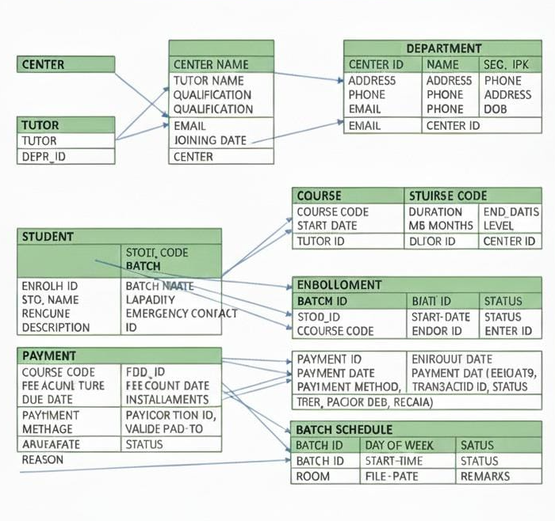

DESCRIPTION OF THE RELATIONS

- CENTER TABLE
Attribute | Data Type | Size | Constraints
CENTER_ID | NUMBER | 4 | PRIMARY KEY
CENTER_NAME | VARCHAR2 | 100 | NOT NULL
EMAIL | VARCHAR2 | 50 | NOT NULL
PHONE | VARCHAR2 | 15 | NOT NULL
ADDRESS | VARCHAR2 | 200 | NOT NULL

- TUTOR TABLE
Attribute | Data Type | Size | Constraints
TUTOR_ID | NUMBER | 4 | PRIMARY KEY
TUTOR_NAME | VARCHAR2 | 50 | NOT NULL
EMAIL | VARCHAR2 | 50 | NOT NULL
PHONE | VARCHAR2 | 15 | NOT NULL
QUALIFICATION | VARCHAR2 | 100 | NOT NULL
JOINING_DATE | DATE | N/A | NOT NULL
CENTER_ID | NUMBER | 4 | FOREIGN KEY REFERENCES  CENTER (CENTER_ID)

- GUARDIAN TABLE
Attribute | Data Type | Size | Constraints
GUARDIAN_ID | NUMBER | 4 | PRIMARY KEY
GUARDIAN_NAME | VARCHAR2 | 50 | NOT NULL
EMAIL | VARCHAR2 | 50 | NOT NULL
RELATION | VARCHAR2 | 20 | NOT NULL
PHONE | VARCHAR2 | 15 | NOT NULL
OCCUPATION | VARCHAR2 | 50 | NONE

- STUDENT TABLE
Attribute | Data Type | Size | Constraints
STD_ID | NUMBER | 4 | PRIMARY KEY
STD_NAME | VARCHAR2 | 50 | NOT NULL
DOB | DATE | N/A | NOT NULL
PHONE | VARCHAR2 | 15 | NOT NULL
EMAIL | VARCHAR2 | 50 | NOT NULL
EMERGENCY_CONTACT | VARCHAR2 | 15 | NOT NULL
GUARDIAN_ID | NUMBER | 4 | FOREIGN KEY REFERENCES  GUARDIAN(GUARDIAN_ID)

- COURSE TABLE
Attribute | Data Type |  | Size | Constraints
COURSE_CODE | VARCHAR2 | 10 |  | PRIMARY KEY
COURSE_NAME | VARCHAR2 | 100 |  | NOT NULL
DURATION_MONTH | NUMBER | 2 |  | CHECK(DURATION_MONTHS>0)
LEVEL | VARCHAR2 | 20 |  | CHECK (LEVEL IN(‘BEGINNER’,’INTERMEDIATE’,  ‘Advanced’))
DESCRIPTION | VARCHAR2 | 200 |  | None

- BATCH TABLE
Attribute | Data Type |  | Size | Constraints
BATCH_ID | NUMBER | 4 |  | PRIMARY KEY
BATCH_CODE | VARCHAR2 | 20 |  | NOT NULL
CAPACITY | NUMBER | 3 |  | CHECK(CAPACITY>0)
START_DATE | DATE | N/A |  | NOT NULL
END_DATE | DATE | N/A |  | NOT NULL
COURSE_CODE | VARCHAR2 | 10 |  | FOREIGN KEY REFERENCES  COURSE(COURSE_CODE)
TUTOR_ID | NUMBER | 4 |  | FOREIGN KEY REFERENCES  TUTOR(TUTOR_ID)
CENTER_ID | NUMBER | 4 |  | FOREIGN KEY REFERENCES  CENTER(CENTER_ID)

- ENROLLMENT TABLE
ATTRIBUTE | DATA TYPE | SIZE | CONSTRAINTS
ENROLL_ID | NUMBER | 4 | PRIMARY KEY
STD_ID | NUMBER | 4 | FOREIGN KEY REFERENCES  STUDENT(STD_ID)
BATCH_ID | NUMBER | 4 | FOREIGN KEY REFERENCES  BATCH(BATCH_ID)
ENROLL_DATE | NUMBER | N/A | NOT NULL
STATUS | VARCHAR2 | 20 | CHECK (STATUS IN(  ‘ACTIVE’,’COMPLETED’,’DROPPED’))
FEES_PAID | NUMBER | 8,2 | CHECK(FEES_PAID>=0)

- FEE_STRUCTURE TABLE
Attribute | Data Type | Size | Constraints
FEE_ID | NUMBER | 4 | PRIMARY KEY
COURSE_CODE | VARCHAR2 | 10 | FOREIGN KEY REFERENCES  COURSE(COURSE_CODE)
FEE_AMOUNT | NUMBER | 8,2 | CHECK(FEE_AMOUNT>0)
INSTALLMENTS | NUMBER | 2 | CHECK(INSTALLMENTS>0)
DUE_DATES | DATE | N/A | NOT NULL
PAYMENT_TERMS | VARCHAR2 | 200 | NONE

- PAYMENT TABLE
Attribute | Data Type | Size | Constraints
PAYMENT_ID | NUMBER | 4 | PRIMARY KEY
ENROLL_ID | NUMBER | 4 | FOREIGN KEY REFERENCES ENROLLMENT(ENROLL_ID)
PAYMENT_DATE | DATE | N/A | NOT NULL
AMOUNT | NUMBER | 8,2 | CHECK (AMOUNT>0)
PAYMENT_METHOD | VARCHAR2 | 20 | CHECK (PAYMENT_METHOD IN (‘CASH’,’CARD’,’ONLINE’))
TRANSACTION_ID | VARCHAR2 | 50 | UNIQUE
STATUS | VARCHAR2 | 20 | CHECK (STATUS IN (‘PAID’,’PENDIND’,’FAILED’))

- BATCH_SCHEDULE TABLE

Attribute | Data Type | Size |  | Constraints
SCHEDULE_ID | NUMBER | 4 | PRIMARY KEY
BATCH_ID | NUMBER | 4 | FOREIGN KEY REFERENCES BATCH(BATCH_ID)
START_TIME | TIME | N/A | NOT NULL
END_TIME | TIME | N/A | NOT NULL
ROOM | VARCHAR2 | 20 | NOT NULL
DAYS_OF_WEEK | VARCHAR2 | 10 | CHECK(DAYS_OF_WEEK IN('Monday', 'Tuesday', 'Wednesday', 'Thursday',  'Friday', 'Saturday', 'Sunday' ))

- ATTENDANCE TABLE
Attribute | Data Type | Size | Constraints
ATTENDENCE_ID | NUMBER | 4 | PRIMARY KEY
ENROLL_ID | NUMBER | 4 | FOREIGN KEY REFERENCES ENROLLMENT(ENROLL_ID)
CLASS_DATE | DATE | N/A | NOT NULL
STATUS | VARCHAR2 | 10 | CHECK (STATUS IN (‘PRESENT’,’ABSENT’,’LATE’))
REMARKS | VARCHAR2 | 100 | NONE

- COURSE_MATERIAL TABLE
Attribute | Data Type | Size | Constraints
MATERIAL_ID | NUMBER | 4 | PRIMARY KEY
BATCH_ID | NUMBER | 4 | FOREIGN KEY REFERENCES BATCH(BATCH_ID)
MATERIAL_NAME | VARCHAR2 | 100 | NOT NULL
FILE_PATH | VARCHAR2 | 100 | NOT NULL
UPLOAD_DATE | DATE | N/A | NOT NULL
MATERIAL_TYPE | VARCHAR2 | 20 | CHECK (MATERIAL_TYPE IN ('Notes',' Assignment', 'Video', 'Presentation'))

- PERFORMANCE TABLE
Attribute | Data Type | Size | Constraints
PREF_ID | NUMBER | 4 | PRIMARY KEY
ENROLL_ID | NUMBER | 4 | FOREIGN KEY REFERENCES ENROLLMENT(ENROLL_ID)
ASSESSMENT_TYPE | VARCHAR2 | 20 | CHECK (ASSESSMENT_TYPE IN ('QUIZ', 'MID', 'FINAL', 'ASSIGNMENT', 'TEST'))
MARKS_OBTAINED | NUMBER | 5,2 | CHECK (MARKS_OBTAINED>=0))
TOTAL_MARKS | NUMBER | 5,2 | CHECK (TOTAL_MARKS >0))
ASSESSMENT_DATE | DATE | N/A | NOT NULL
REMARKS | VARCHAR2 | 100 | NONE

- COURSE_PREREUISITE TABLE

Attribute | Data Type | Size | Constraints
COURSE_CODE | VARCHAR2 | 10 | PRIMARY KEY, FOREIGN KEY REFERENCES COURSE(COURSE_CODE)
PREREQ_CODE | VARCHAR2 | 10 | PRIMARY KEY, FOREIGN KEY REFERENCES COURSES(COURSE_CODE)
MIN_GRADE | VARCHAR2 | 2 | CHECK (MIN_GRADE IN ('A', 'B', 'C', 'D', 'F'))

TABLES CREATION USING SQL

1) CENTER TABLE
CREATE TABLE CENTER
(
CENTER_ID NUMBER (4) CONSTRAINT CENTER_PK PRIMARY KEY,
CENTER_NAME VARCHAR2(100) CONSTRAINT CENTER_NAME_NN NOT NULL,
ADDRESS VARCHAR2(200) CONSTRAINT CENTER_ADDR_NN NOT NULL,
PHONE VARCHAR2(15) CONSTRAINT CENTER_PHONE_NN NOT NULL,
EMAIL VARCHAR2(50) CONSTRAINT CENTER_EMAIL_NN NOT NULL
);
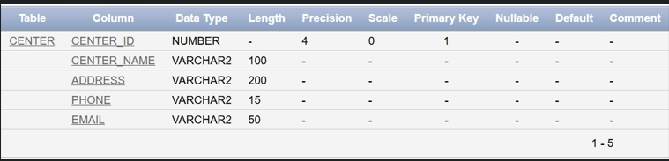

2) TUTOR TABLE
CREATE TABLE TUTOR
(
TUTOR_ID NUMBER (4) CONSTRAINT TUTOR_PK PRIMARY KEY,
TUTOR_NAME VARCHAR2(50) CONSTRAINT TUTOR_NAME_NN NOT NULL,
QUALIFICATION VARCHAR2(100) CONSTRAINT TUTOR_QUAL_NN NOT NULL,
PHONE VARCHAR2(15) CONSTRAINT TUTOR_PHONE_NN NOT NULL,
EMAIL VARCHAR2(50) CONSTRAINT TUTOR_EMAIL_NN NOT NULL,
JOINING_DATE DATE CONSTRAINT TUTOR_JOIN_NN NOT NULL,
CENTER_ID NUMBER (4) CONSTRAINT TUTOR_CENTER_FK REFERENCES CENTER(CENTER_ID)
);
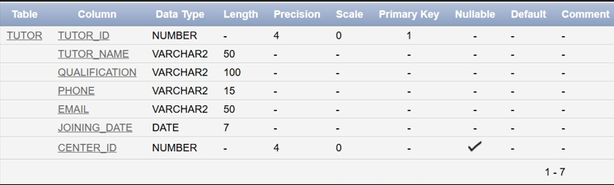

GUARDIAN TABLE
CREATE TABLE GUARDIAN
(
GUARDIAN_ID NUMBER (4) CONSTRAINT GUARDIAN_PK PRIMARY KEY,
GUARDIAN_NAME VARCHAR2(50) CONSTRAINT GUARDIAN_NAME_NN NOT NULL,
RELATION VARCHAR2(20) CONSTRAINT GUARDIAN_REL_NN NOT NULL,
PHONE VARCHAR2(15) CONSTRAINT GUARDIAN_PHONE_NN NOT NULL,
EMAIL VARCHAR2(50) CONSTRAINT GUARDIAN_EMAIL_NN NOT NULL,
OCCUPATION VARCHAR2(50)
);

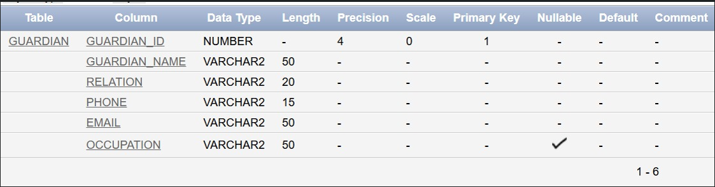

STUDENT TABLE
CREATE TABLE STUDENT
(
STD_ID NUMBER (4) CONSTRAINT STUDENT_PK PRIMARY KEY,
STD_NAME VARCHAR2(50) CONSTRAINT STUDENT_NAME_NN NOT NULL,
DOB DATE CONSTRAINT STUDENT_DOB_NN NOT NULL,
PHONE VARCHAR2(15) CONSTRAINT STUDENT_PHONE_NN NOT NULL,
EMAIL VARCHAR2(50) CONSTRAINT STUDENT_EMAIL_NN NOT NULL,
EMERGENCY_CONTACT VARCHAR2(15) CONSTRAINT STUDENT_EMERG_NN NOT NULL,
GUARDIAN_ID NUMBER (4) CONSTRAINT STUDENT_GUARDIAN_FK REFERENCES GUARDIAN(GUARDIAN_ID)
);
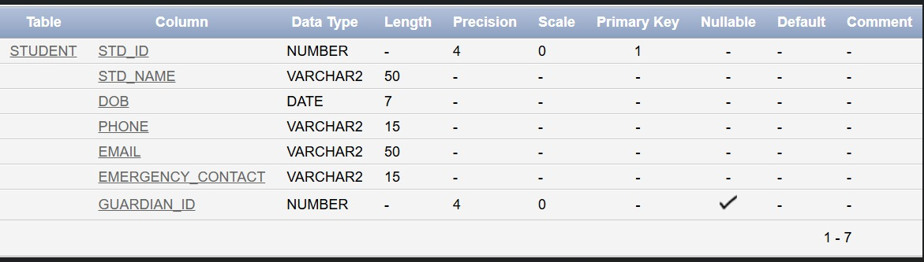

COURSE TABLE
CREATE TABLE COURSE
(
COURSE_CODE VARCHAR2(10) CONSTRAINT COURSE_PK PRIMARY KEY,
COURSE_NAME VARCHAR2(100) CONSTRAINT COURSE_NAME_NN NOT NULL,
DURATION_MONTHS NUMBER (2) CONSTRAINT DURATION_CK CHECK (DURATION_MONTHS > 0),
COURSE_LEVEL VARCHAR2(20) CONSTRAINT LEVEL_CK CHECK (COURSE_LEVEL IN ('Beginner', 'Intermediate', 'Advanced')),
DESCRIPTION VARCHAR2(200)

);
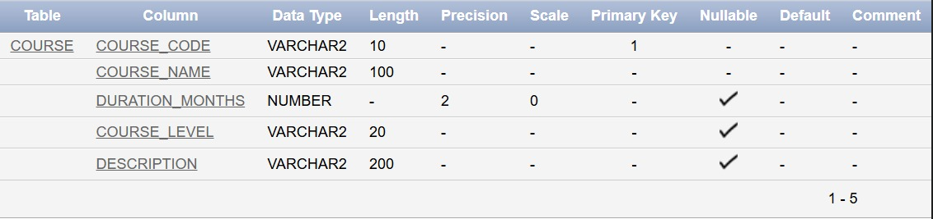

BATCH TABLE
CREATE TABLE BATCH
(
BATCH_ID NUMBER (4) CONSTRAINT BATCH_PK PRIMARY KEY,
BATCH_CODE VARCHAR2(20) CONSTRAINT BATCH_CODE_NN NOT NULL,
CAPACITY NUMBER (3) CONSTRAINT CAPACITY_CK CHECK (CAPACITY > 0),
START_DATE DATE CONSTRAINT START_DATE_NN NOT NULL,
END_DATE DATE CONSTRAINT END_DATE_NN NOT NULL,
COURSE_CODE VARCHAR2(10) CONSTRAINT BATCH_COURSE_FK REFERENCES COURSE(COURSE_CODE),
TUTOR_ID NUMBER (4) CONSTRAINT BATCH_TUTOR_FK REFERENCES TUTOR(TUTOR_ID),
CENTER_ID NUMBER (4) CONSTRAINT BATCH_CENTER_FK REFERENCES CENTER(CENTER_ID)
);

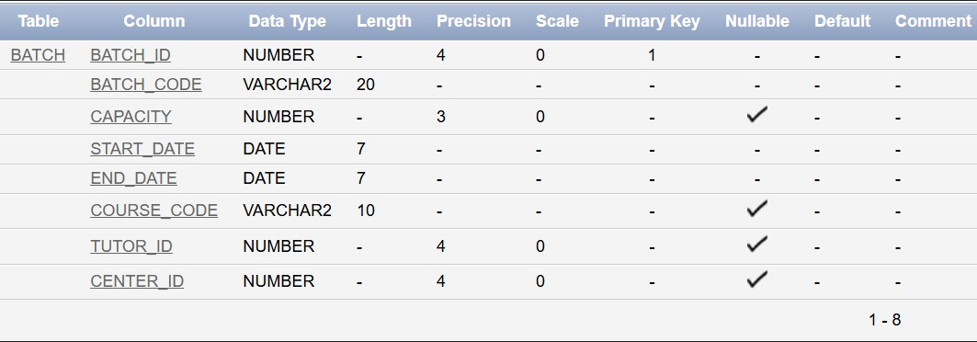

ENROLLMENT TABLE
CREATE TABLE ENROLLMENT
(
ENROLL_ID NUMBER (4) CONSTRAINT ENROLL_PK PRIMARY KEY,
STD_ID NUMBER (4) CONSTRAINT ENROLL_STUDENT_FK REFERENCES STUDENT(STD_ID),
BATCH_ID NUMBER (4) CONSTRAINT ENROLL_BATCH_FK REFERENCES BATCH(BATCH_ID),
ENROLL_DATE DATE CONSTRAINT ENROLL_DATE_NN NOT NULL,
STATUS VARCHAR2(20) CONSTRAINT STATUS_CK CHECK (STATUS IN ('Active', 'Completed', 'Dropped')),
FEES_PAID NUMBER (8,2) CONSTRAINT FEES_CK CHECK (FEES_PAID >= 0)
);
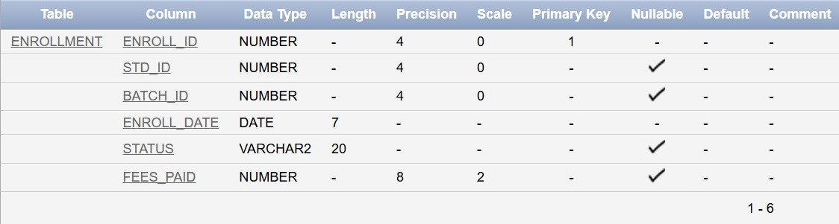

FEE_STRUCTURE TABLE
CREATE TABLE FEE_STRUCTURE
(
FEE_ID NUMBER (4) CONSTRAINT FEE_PK PRIMARY KEY,
COURSE_CODE VARCHAR2(10) CONSTRAINT FEE_COURSE_FK REFERENCES COURSE(COURSE_CODE),
FEE_AMOUNT NUMBER (8,2) CONSTRAINT FEE_AMOUNT_CK CHECK (FEE_AMOUNT > 0),
INSTALLMENTS NUMBER (2) CONSTRAINT INSTALLMENTS_CK CHECK (INSTALLMENTS > 0),
DUE_DATE DATE CONSTRAINT DUE_DATE_NN NOT NULL,
PAYMENT_TERMS VARCHAR2(200)
);
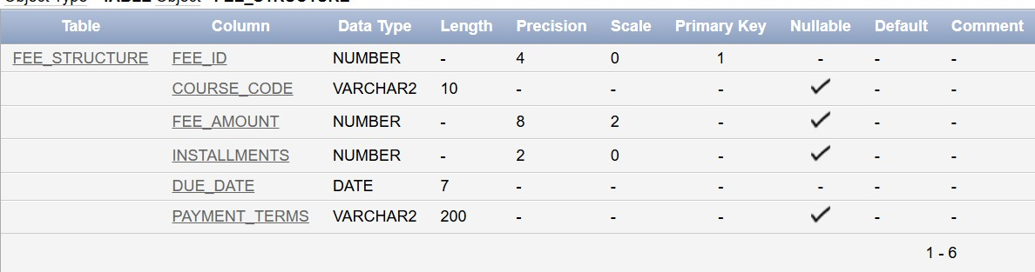

PAYMENT TABLE
CREATE TABLE PAYMENT
(
PAYMENT_ID NUMBER (4) CONSTRAINT PAYMENT_PK PRIMARY KEY,
ENROLL_ID NUMBER (4) CONSTRAINT PAYMENT_ENROLL_FK REFERENCES ENROLLMENT(ENROLL_ID),
PAYMENT_DATE DATE CONSTRAINT PAYMENT_DATE_NN NOT NULL,
AMOUNT NUMBER (8,2) CONSTRAINT AMOUNT_CK CHECK (AMOUNT > 0),
PAYMENT_METHOD VARCHAR2(20) CONSTRAINT PAYMENT_METHOD_CK CHECK (PAYMENT_METHOD IN ('Cash', 'Card', 'Online')),
TRANSACTION_ID VARCHAR2(50) CONSTRAINT TRANSACTION_UNIQUE UNIQUE,
STATUS VARCHAR2(20) CONSTRAINT PAYMENT_STATUS_CK CHECK (STATUS IN ('Paid', 'Pending', 'Failed'))
);
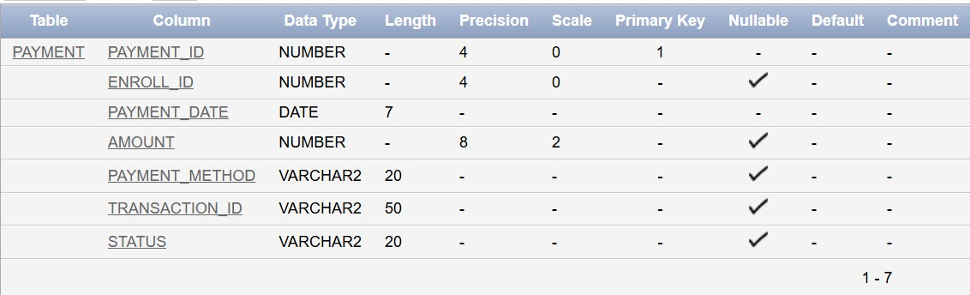

BATCH_SCHEDULE TABLE
CREATE TABLE BATCH_SCHEDULE
(
SCHEDULE_ID NUMBER (4) CONSTRAINT SCHEDULE_PK PRIMARY KEY,
BATCH_ID NUMBER (4) CONSTRAINT SCHEDULE_BATCH_FK REFERENCES BATCH(BATCH_ID),
DAY_OF_WEEK VARCHAR2(10) CONSTRAINT DAY_CK CHECK (DAY_OF_WEEK IN ('Monday','Tuesday','Wednesday','Thursday','Friday','Saturday','Sunday')),
START_TIME VARCHAR2(8) CONSTRAINT START_TIME_NN NOT NULL,
END_TIME VARCHAR2(8) CONSTRAINT END_TIME_NN NOT NULL,
ROOM VARCHAR2(20) CONSTRAINT ROOM_NN NOT NULL
);
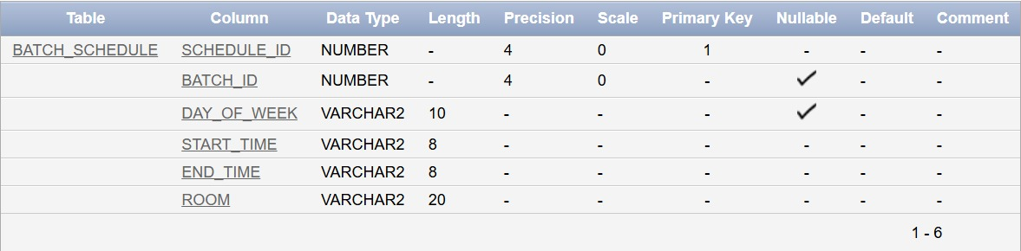

ATTENDENCE TABLE
CREATE TABLE ATTENDANCE
(
ATTENDANCE_ID NUMBER (4) CONSTRAINT ATTENDANCE_PK PRIMARY KEY,
ENROLL_ID NUMBER (4) CONSTRAINT ATTENDANCE_ENROLL_FK REFERENCES ENROLLMENT(ENROLL_ID),
CLASS_DATE DATE CONSTRAINT CLASS_DATE_NN NOT NULL,
STATUS VARCHAR2(10) CONSTRAINT ATTENDANCE_STATUS_CK CHECK (STATUS IN ('Present', 'Absent', 'Late')),
REMARKS VARCHAR2(100)
);
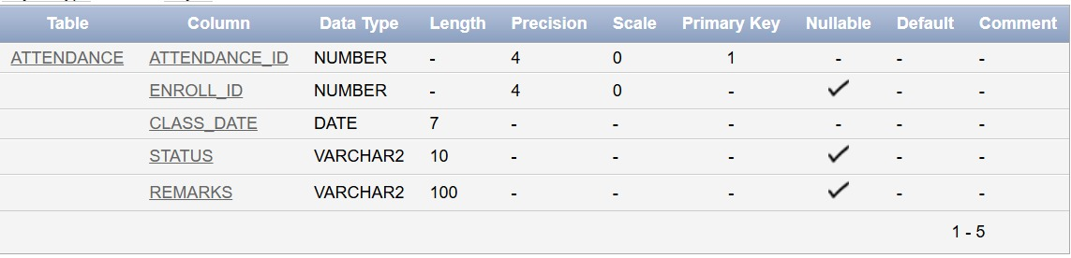

COURSE_MATERIAL TABLE
CREATE TABLE COURSE_MATERIAL
(
MATERIAL_ID NUMBER (4) CONSTRAINT MATERIAL_PK PRIMARY KEY,
BATCH_ID NUMBER (4) CONSTRAINT MATERIAL_BATCH_FK REFERENCES BATCH(BATCH_ID),
MATERIAL_NAME VARCHAR2(100) CONSTRAINT MATERIAL_NAME_NN NOT NULL,
MATERIAL_TYPE VARCHAR2(20) CONSTRAINT MATERIAL_TYPE_CK CHECK (MATERIAL_TYPE IN ('Notes', 'Assignment', 'Video', 'Presentation')),
UPLOAD_DATE DATE CONSTRAINT UPLOAD_DATE_NN NOT NULL,
FILE_PATH VARCHAR2(200) CONSTRAINT FILE_PATH_NN NOT NULL
);
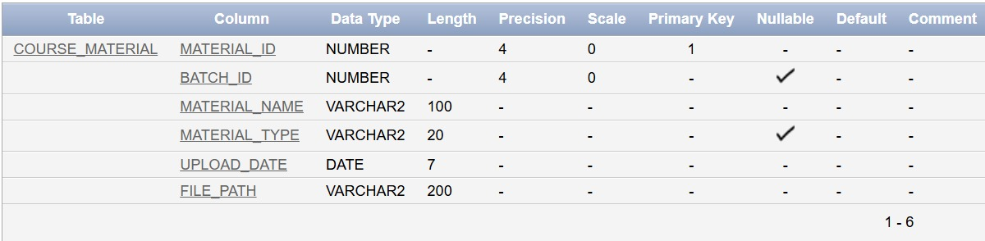

PERFORMANCE TABLE
CREATE TABLE PERFORMANCE
(
PERF_ID NUMBER (4) CONSTRAINT PERFORMANCE_PK PRIMARY KEY,
ENROLL_ID NUMBER (4) CONSTRAINT PERFORMANCE_ENROLL_FK REFERENCES ENROLLMENT(ENROLL_ID),
ASSESSMENT_TYPE VARCHAR2(20) CONSTRAINT ASSESSMENT_TYPE_CK CHECK (ASSESSMENT_TYPE IN ('Quiz', 'Test', 'Midterm', 'Final', 'Assignment')),
MARKS_OBTAINED NUMBER (5,2) CONSTRAINT MARKS_CK CHECK (MARKS_OBTAINED >= 0),
TOTAL_MARKS NUMBER (5,2) CONSTRAINT TOTAL_MARKS_CK CHECK (TOTAL_MARKS > 0),
ASSESSMENT_DATE DATE CONSTRAINT ASSESSMENT_DATE_NN NOT NULL,
REMARKS VARCHAR2(100)
);

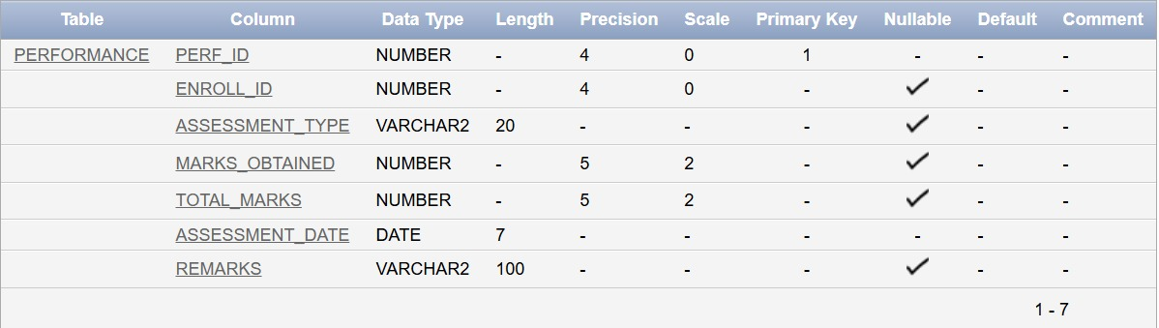

COURSE_PREREQUISITE TABLE
CREATE TABLE COURSE_PREREQUISITE
(
COURSE_CODE VARCHAR2(10) CONSTRAINT PREREQ_COURSE_FK REFERENCES COURSE(COURSE_CODE),
PREREQ_CODE VARCHAR2(10) CONSTRAINT PREREQ_PRECOURSE_FK REFERENCES COURSE(COURSE_CODE),
MIN_GRADE VARCHAR2(2) CONSTRAINT MIN_GRADE_CK CHECK (MIN_GRADE IN ('A','B','C','D','F')),
CONSTRAINT COURSE_PREREQ_PK PRIMARY KEY (COURSE_CODE, PREREQ_CODE)
);
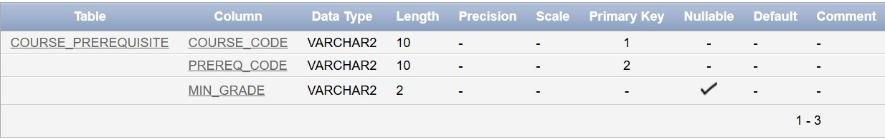

INSERTION OF DATA IN THE TABLES

- CENTER TABLE
INSERT INTO CENTER (CENTER_ID, CENTER_NAME, ADDRESS, PHONE, EMAIL)
VALUES (1, 'Al-Madina Tuition Center', '123 Main Street, Lahore', '042-1234567', 'info@almadina.edu.pk');

INSERT INTO CENTER (CENTER_ID, CENTER_NAME, ADDRESS, PHONE, EMAIL)
VALUES (2, 'Bright Future Academy', '456 Gulberg, Lahore', '042-7654321', 'contact@brightfuture.edu.pk');

INSERT INTO CENTER (CENTER_ID, CENTER_NAME, ADDRESS, PHONE, EMAIL)
VALUES (3, 'Knowledge Hub', '789 Model Town, Lahore', '042-9876543', 'admin@knowledgehub.edu.pk'
);

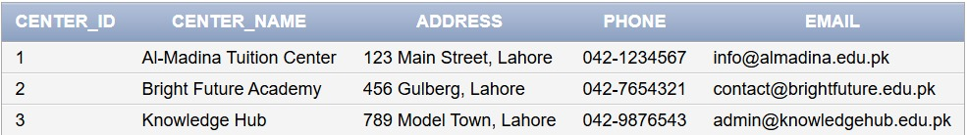

TUTOR TABLE
INSERT INTO TUTOR (TUTOR_ID, TUTOR_NAME, QUALIFICATION, PHONE, EMAIL, JOINING_DATE, CENTER_ID) VALUES (1, 'Dr Ahmed Khan', 'PhD Mathematics', '0300-1111111', 'ahmed.khan@center.edu.pk', TO_DATE ('2022-01-15', 'YYYY-MM-DD'), 1);
INSERT INTO TUTOR (TUTOR_ID, TUTOR_NAME, QUALIFICATION, PHONE, EMAIL, JOINING_DATE, CENTER_ID) VALUES (2, 'Miss Sara Ali', 'MSc Physics', '0300-2222222', 'sara.ali@center.edu.pk', TO_DATE ('2022-03-20', 'YYYY-MM-DD'), 1);
INSERT INTO TUTOR (TUTOR_ID, TUTOR_NAME, QUALIFICATION, PHONE, EMAIL, JOINING_DATE, CENTER_ID) VALUES (3, 'M Bilal Raza', 'MSc Computer Science', '0300-3333333', 'bilal.raza@center.edu.pk', TO_DATE ('2021-11-10', 'YYYY-MM-DD'), 2);
INSERT INTO TUTOR (TUTOR_ID, TUTOR_NAME, QUALIFICATION, PHONE, EMAIL, JOINING_DATE, CENTER_ID) VALUES (4, 'Miss Fatima Noor', 'MA English Literature', '0300-4444444', 'fatima.noor@center.edu.pk', TO_DATE ('2023-02-05', 'YYYY-MM-DD'), 2);
INSERT INTO TUTOR (TUTOR_ID, TUTOR_NAME, QUALIFICATION, PHONE, EMAIL, JOINING_DATE, CENTER_ID) VALUES (5, 'Dr Usman Ahmed', 'PhD Chemistry', '0300-5555555', 'usman.ahmed@center.edu.pk', TO_DATE ('2020-08-25', 'YYYY-MM-DD'), 3);
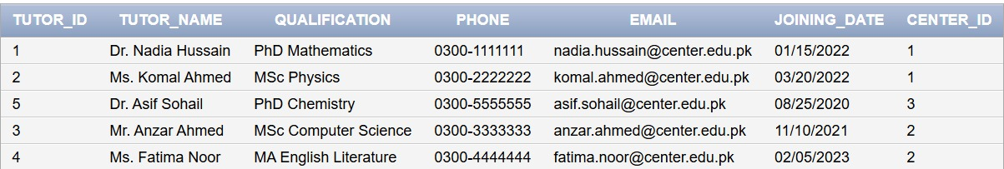

GUARDIAN TABLE
INSERT INTO GUARDIAN (GUARDIAN_ID, GUARDIAN_NAME, RELATION, PHONE, EMAIL, OCCUPATION)
VALUES (1, 'Muhammad Asif', 'Father', '0300-6666666', 'asif@gmail.com', 'Businessman');

INSERT INTO GUARDIAN (GUARDIAN_ID, GUARDIAN_NAME, RELATION, PHONE, EMAIL, OCCUPATION)
VALUES (2, 'Ayesha Raza', 'Mother', '0300-7777777', 'ayesha@gmail.com', 'Teacher');

INSERT INTO GUARDIAN (GUARDIAN_ID, GUARDIAN_NAME, RELATION, PHONE, EMAIL, OCCUPATION)
VALUES (3, 'Khalid Mahmood', 'Father', '0300-8888888', 'khalid@gmail.com', 'Engineer');

INSERT INTO GUARDIAN (GUARDIAN_ID, GUARDIAN_NAME, RELATION, PHONE, EMAIL, OCCUPATION)
VALUES (4, 'Sadia Khan', 'Mother', '0300-9999999', 'sadia@gmail.com', 'Doctor');

INSERT INTO GUARDIAN (GUARDIAN_ID, GUARDIAN_NAME, RELATION, PHONE, EMAIL, OCCUPATION)
VALUES (5, 'Rizwan Ali', 'Father', '0300-1010101', 'rizwan@gmail.com', 'Banker');
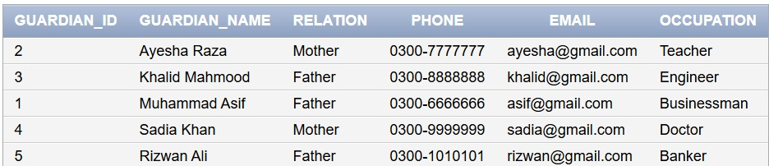

STUDENT TABLE
INSERT INTO STUDENT (STD_ID, STD_NAME, DOB, PHONE, EMAIL, EMERGENCY_CONTACT, GUARDIAN_ID)
VALUES (1, 'Ali Ahmed', TO_DATE('2008-05-15', 'YYYY-MM-DD'), '0321-1234567', 'ali.ahmed@student.com', '0300-6666666', 1);
INSERT INTO STUDENT (STD_ID, STD_NAME, DOB, PHONE, EMAIL, EMERGENCY_CONTACT, GUARDIAN_ID)
VALUES (2, 'Fatima Khan', TO_DATE('2009-08-22', 'YYYY-MM-DD'), '0321-2345678', 'fatima.khan@student.com', '0300-7777777', 2);
INSERT INTO STUDENT (STD_ID, STD_NAME, DOB, PHONE, EMAIL, EMERGENCY_CONTACT, GUARDIAN_ID)
VALUES (3, 'Ali Raza', TO_DATE('2007-03-10', 'YYYY-MM-DD'), '0321-3456789', 'usman.raza@student.com', '0300-8888888', 3);
INSERT INTO STUDENT (STD_ID, STD_NAME, DOB, PHONE, EMAIL, EMERGENCY_CONTACT, GUARDIAN_ID)
VALUES (4, 'Ayesha Rani', TO_DATE('2010-11-30', 'YYYY-MM-DD'), '0321-4567890', 'ayesha.malik@student.com', '0300-9999999', 4);
INSERT INTO STUDENT (STD_ID, STD_NAME, DOB, PHONE, EMAIL, EMERGENCY_CONTACT, GUARDIAN_ID)
VALUES (5, 'Tooba Ahmed', TO_DATE('2009-07-18', 'YYYY-MM-DD'), '0321-5678901', 'bilal.hassan@student.com', '0300-1010101', 5);

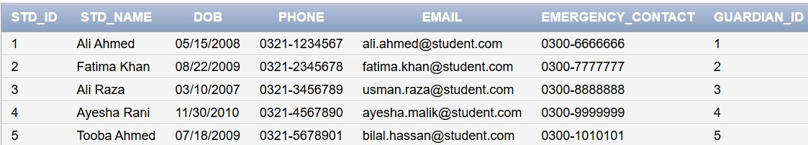

COURSE TABLE
INSERT INTO COURSE (COURSE_CODE, COURSE_NAME, DURATION_MONTHS, COURSE_LEVEL, DESCRIPTION)
VALUES ('MAT101', 'Basic Mathematics', 3, 'Beginner', 'Foundation course for basic mathematics concepts');

INSERT INTO COURSE (COURSE_CODE, COURSE_NAME, DURATION_MONTHS, COURSE_LEVEL, DESCRIPTION)
VALUES ('MAT201', 'Advanced Mathematics', 4, 'Advanced', 'Advanced mathematics for competitive exams');

INSERT INTO COURSE (COURSE_CODE, COURSE_NAME, DURATION_MONTHS, COURSE_LEVEL, DESCRIPTION)
VALUES ('PHY101', 'Physics Fundamentals', 3, 'Beginner', 'Basic concepts of physics');

INSERT INTO COURSE (COURSE_CODE, COURSE_NAME, DURATION_MONTHS, COURSE_LEVEL, DESCRIPTION)
VALUES ('CS101', 'Programming Fundamentals', 4, 'Intermediate', 'Introduction to programming with C++');

INSERT INTO COURSE (COURSE_CODE, COURSE_NAME, DURATION_MONTHS, COURSE_LEVEL, DESCRIPTION)
VALUES ('ENG101', 'English Language', 3, 'Beginner', 'Basic English grammar and communication');

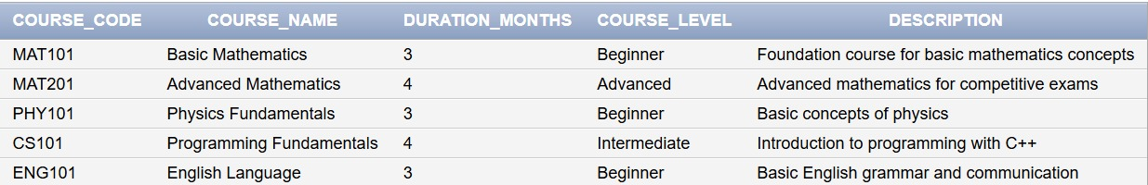

BATCH TABLE
INSERT INTO BATCH (BATCH_ID, BATCH_CODE, CAPACITY, START_DATE, END_DATE, COURSE_CODE, TUTOR_ID, CENTER_ID)
VALUES (1, 'MAT-2024-A', 20, TO_DATE('2024-01-01', 'YYYY-MM-DD'), TO_DATE('2024-03-31', 'YYYY-MM-DD'), 'MAT101', 1, 1);

INSERT INTO BATCH (BATCH_ID, BATCH_CODE, CAPACITY, START_DATE, END_DATE, COURSE_CODE, TUTOR_ID, CENTER_ID)
VALUES (2, 'PHY-2024-A', 15, TO_DATE('2024-02-01', 'YYYY-MM-DD'), TO_DATE('2024-04-30', 'YYYY-MM-DD'), 'PHY101', 2, 1);

INSERT INTO BATCH (BATCH_ID, BATCH_CODE, CAPACITY, START_DATE, END_DATE, COURSE_CODE, TUTOR_ID, CENTER_ID)
VALUES (3, 'CS-2024-A', 25, TO_DATE('2024-01-15', 'YYYY-MM-DD'), TO_DATE('2024-05-15', 'YYYY-MM-DD'), 'CS101', 3, 2);

INSERT INTO BATCH (BATCH_ID, BATCH_CODE, CAPACITY, START_DATE, END_DATE, COURSE_CODE, TUTOR_ID, CENTER_ID)
VALUES (4, 'ENG-2024-A', 30, TO_DATE('2024-03-01', 'YYYY-MM-DD'), TO_DATE('2024-05-31', 'YYYY-MM-DD'), 'ENG101', 4, 2);

INSERT INTO BATCH (BATCH_ID, BATCH_CODE, CAPACITY, START_DATE, END_DATE, COURSE_CODE, TUTOR_ID, CENTER_ID)
VALUES (5, 'MAT-2024-ADV', 18, TO_DATE('2024-02-15', 'YYYY-MM-DD'), TO_DATE('2024-06-15', 'YYYY-MM-DD'), 'MAT201', 5, 3);

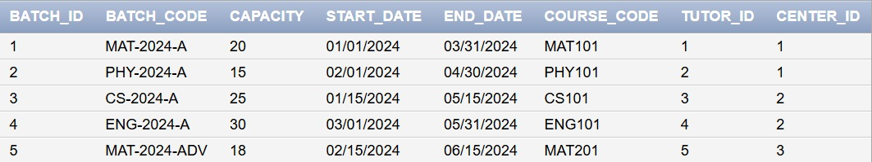

ENROLLMENT TABLE
INSERT INTO ENROLLMENT (ENROLL_ID, STD_ID, BATCH_ID, ENROLL_DATE, STATUS, FEES_PAID)
VALUES (1, 1, 1, TO_DATE('2023-12-20', 'YYYY-MM-DD'), 'Active', 5000);

INSERT INTO ENROLLMENT (ENROLL_ID, STD_ID, BATCH_ID, ENROLL_DATE, STATUS, FEES_PAID)
VALUES (2, 2, 1, TO_DATE('2023-12-22', 'YYYY-MM-DD'), 'Active', 5000);

INSERT INTO ENROLLMENT (ENROLL_ID, STD_ID, BATCH_ID, ENROLL_DATE, STATUS, FEES_PAID)
VALUES (3, 3, 2, TO_DATE('2024-01-10', 'YYYY-MM-DD'), 'Active', 6000);

INSERT INTO ENROLLMENT (ENROLL_ID, STD_ID, BATCH_ID, ENROLL_DATE, STATUS, FEES_PAID)
VALUES (4, 4, 3, TO_DATE('2024-01-05', 'YYYY-MM-DD'), 'Active', 8000);

INSERT INTO ENROLLMENT (ENROLL_ID, STD_ID, BATCH_ID, ENROLL_DATE, STATUS, FEES_PAID)
VALUES (5, 5, 4, TO_DATE('2024-02-20', 'YYYY-MM-DD'), 'Active', 4000);

INSERT INTO ENROLLMENT (ENROLL_ID, STD_ID, BATCH_ID, ENROLL_DATE, STATUS, FEES_PAID)
VALUES (6, 1, 5, TO_DATE('2024-02-01', 'YYYY-MM-DD'), 'Active', 7000);

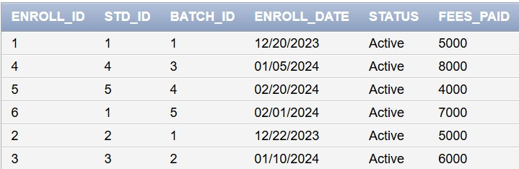

PAYMENT TABLE
INSERT INTO PAYMENT (PAYMENT_ID, ENROLL_ID, PAYMENT_DATE, AMOUNT, PAYMENT_METHOD, TRANSACTION_ID, STATUS)
VALUES (1, 1, TO_DATE('2023-12-20', 'YYYY-MM-DD'), 2500, 'Cash', 'TXN001', 'Paid');

INSERT INTO PAYMENT (PAYMENT_ID, ENROLL_ID, PAYMENT_DATE, AMOUNT, PAYMENT_METHOD, TRANSACTION_ID, STATUS)
VALUES (2, 2, TO_DATE('2023-12-22', 'YYYY-MM-DD'), 2500, 'Online', 'TXN002', 'Paid');
INSERT INTO PAYMENT (PAYMENT_ID, ENROLL_ID, PAYMENT_DATE, AMOUNT, PAYMENT_METHOD, TRANSACTION_ID, STATUS)
VALUES (3, 3, TO_DATE('2024-01-10', 'YYYY-MM-DD'), 2000, 'Card', 'TXN003', 'Paid');

INSERT INTO PAYMENT (PAYMENT_ID, ENROLL_ID, PAYMENT_DATE, AMOUNT, PAYMENT_METHOD, TRANSACTION_ID, STATUS)
VALUES (4, 4, TO_DATE('2024-01-05', 'YYYY-MM-DD'), 2000, 'Cash', 'TXN004', 'Paid');

INSERT INTO PAYMENT (PAYMENT_ID, ENROLL_ID, PAYMENT_DATE, AMOUNT, PAYMENT_METHOD, TRANSACTION_ID, STATUS)
VALUES (5, 5, TO_DATE('2024-02-20', 'YYYY-MM-DD'), 2000, 'Online', 'TXN005', 'Paid');

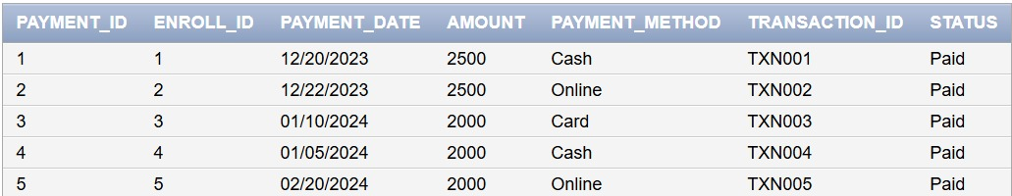

ATTENDANCE TABLE
INSERT INTO ATTENDANCE (ATTENDANCE_ID, ENROLL_ID, CLASS_DATE, STATUS, REMARKS)
VALUES (1, 1, TO_DATE('2024-01-01', 'YYYY-MM-DD'), 'Present', NULL);

INSERT INTO ATTENDANCE (ATTENDANCE_ID, ENROLL_ID, CLASS_DATE, STATUS, REMARKS)
VALUES (2, 1, TO_DATE('2024-01-03', 'YYYY-MM-DD'), 'Present', NULL);

INSERT INTO ATTENDANCE (ATTENDANCE_ID, ENROLL_ID, CLASS_DATE, STATUS, REMARKS)
VALUES (3, 2, TO_DATE('2024-01-01', 'YYYY-MM-DD'), 'Absent', 'Sick');

INSERT INTO ATTENDANCE (ATTENDANCE_ID, ENROLL_ID, CLASS_DATE, STATUS, REMARKS)
VALUES (4, 3, TO_DATE('2024-02-06', 'YYYY-MM-DD'), 'Present', NULL);

INSERT INTO ATTENDANCE (ATTENDANCE_ID, ENROLL_ID, CLASS_DATE, STATUS, REMARKS)
VALUES (5, 4, TO_DATE('2024-01-15', 'YYYY-MM-DD'), 'Late', 'Traffic delay');

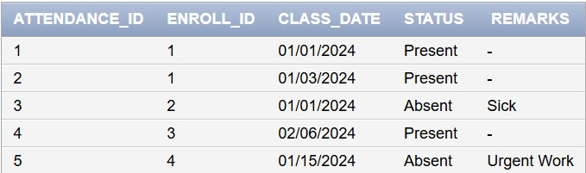

BATCH_SCHEDULE TABLE
INSERT INTO BATCH_SCHEDULE (SCHEDULE_ID, BATCH_ID, DAY_OF_WEEK, START_TIME, END_TIME, ROOM)
VALUES (1, 1, 'Monday', '02:00 PM', '04:00 PM', 'Room 101');

INSERT INTO BATCH_SCHEDULE (SCHEDULE_ID, BATCH_ID, DAY_OF_WEEK, START_TIME, END_TIME, ROOM)
VALUES (2, 1, 'Wednesday', '02:00 PM', '04:00 PM', 'Room 101');

INSERT INTO BATCH_SCHEDULE (SCHEDULE_ID, BATCH_ID, DAY_OF_WEEK, START_TIME, END_TIME, ROOM)
VALUES (3, 2, 'Tuesday', '03:00 PM', '05:00 PM', 'Room 102');

INSERT INTO BATCH_SCHEDULE (SCHEDULE_ID, BATCH_ID, DAY_OF_WEEK, START_TIME, END_TIME, ROOM)
VALUES (4, 2, 'Thursday', '03:00 PM', '05:00 PM', 'Room 102');

INSERT INTO BATCH_SCHEDULE (SCHEDULE_ID, BATCH_ID, DAY_OF_WEEK, START_TIME, END_TIME, ROOM)
VALUES (5, 3, 'Monday', '04:00 PM', '06:00 PM', 'Computer Lab');

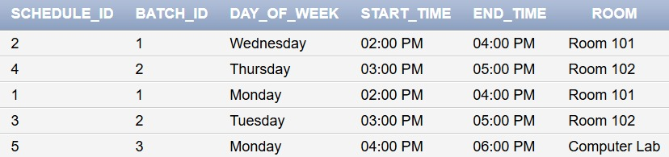

FEE_STRUCTURE TABLE
INSERT INTO FEE_STRUCTURE (FEE_ID, COURSE_CODE, FEE_AMOUNT, INSTALLMENTS, DUE_DATE, PAYMENT_TERMS)
VALUES (1, 'MAT101', 5000, 2, TO_DATE('2024-02-15', 'YYYY-MM-DD'), '50% on enrollment, 50% before mid-course');

INSERT INTO FEE_STRUCTURE (FEE_ID, COURSE_CODE, FEE_AMOUNT, INSTALLMENTS, DUE_DATE, PAYMENT_TERMS)
VALUES (2, 'PHY101', 6000, 3, TO_DATE('2024-03-15', 'YYYY-MM-DD'), '3 installments allowed');

INSERT INTO FEE_STRUCTURE (FEE_ID, COURSE_CODE, FEE_AMOUNT, INSTALLMENTS, DUE_DATE, PAYMENT_TERMS)
VALUES (3, 'CS101', 8000, 4, TO_DATE('2024-03-01', 'YYYY-MM-DD'), 'Monthly installments');

INSERT INTO FEE_STRUCTURE (FEE_ID, COURSE_CODE, FEE_AMOUNT, INSTALLMENTS, DUE_DATE, PAYMENT_TERMS)
VALUES (4, 'ENG101', 4000, 2, TO_DATE('2024-04-01', 'YYYY-MM-DD'), 'Full payment or 2 installments');

INSERT INTO FEE_STRUCTURE (FEE_ID, COURSE_CODE, FEE_AMOUNT, INSTALLMENTS, DUE_DATE, PAYMENT_TERMS)
VALUES (5, 'MAT201', 7000, 3, TO_DATE('2024-04-15', 'YYYY-MM-DD'), '3 equal installments');

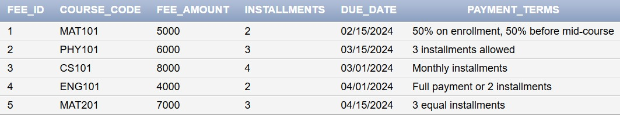

COURSE_MATERIAL TABLE
INSERT INTO COURSE_MATERIAL (MATERIAL_ID, BATCH_ID, MATERIAL_NAME, MATERIAL_TYPE, UPLOAD_DATE, FILE_PATH)
VALUES (1, 1, 'Algebra Basics', 'Notes', TO_DATE('2024-01-01', 'YYYY-MM-DD'), '/materials/math/algebra.pdf');

INSERT INTO COURSE_MATERIAL (MATERIAL_ID, BATCH_ID, MATERIAL_NAME, MATERIAL_TYPE, UPLOAD_DATE, FILE_PATH)
VALUES (2, 1, 'Week 1 Assignment', 'Assignment', TO_DATE('2024-01-05', 'YYYY-MM-DD'), '/materials/math/assignment1.pdf');

INSERT INTO COURSE_MATERIAL (MATERIAL_ID, BATCH_ID, MATERIAL_NAME, MATERIAL_TYPE, UPLOAD_DATE, FILE_PATH)
VALUES (3, 3, 'C++ Introduction Video', 'Video', TO_DATE('2024-01-15', 'YYYY-MM-DD'), '/materials/cs/cpp_intro.mp4');

INSERT INTO COURSE_MATERIAL (MATERIAL_ID, BATCH_ID, MATERIAL_NAME, MATERIAL_TYPE, UPLOAD_DATE, FILE_PATH)
VALUES (4, 2, 'Physics Formulas', 'Notes', TO_DATE('2024-02-01', 'YYYY-MM-DD'), '/materials/physics/formulas.pdf');

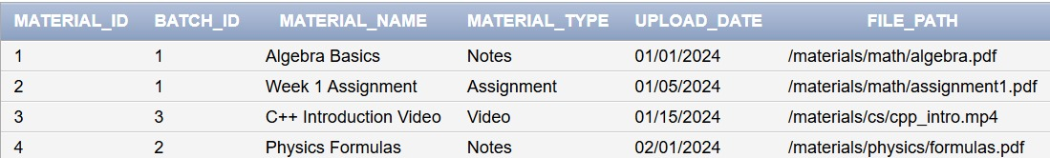

PERFORMANCE TABLE

INSERT INTO PERFORMANCE (PERF_ID, ENROLL_ID, ASSESSMENT_TYPE, MARKS_OBTAINED, TOTAL_MARKS, ASSESSMENT_DATE, REMARKS)
VALUES (1, 1, 'Quiz', 18, 20, TO_DATE('2024-01-10', 'YYYY-MM-DD'), 'Excellent');

INSERT INTO PERFORMANCE (PERF_ID, ENROLL_ID, ASSESSMENT_TYPE, MARKS_OBTAINED, TOTAL_MARKS, ASSESSMENT_DATE, REMARKS)
VALUES (2, 1, 'Test', 42, 50, TO_DATE('2024-01-25', 'YYYY-MM-DD'), 'Good performance');

INSERT INTO PERFORMANCE (PERF_ID, ENROLL_ID, ASSESSMENT_TYPE, MARKS_OBTAINED, TOTAL_MARKS, ASSESSMENT_DATE, REMARKS)
VALUES (3, 2, 'Quiz', 15, 20, TO_DATE('2024-01-10', 'YYYY-MM-DD'), 'Needs improvement');

INSERT INTO PERFORMANCE (PERF_ID, ENROLL_ID, ASSESSMENT_TYPE, MARKS_OBTAINED, TOTAL_MARKS, ASSESSMENT_DATE, REMARKS)
VALUES (4, 3, 'Assignment', 48, 50, TO_DATE('2024-02-15', 'YYYY-MM-DD'), 'Excellent work');

INSERT INTO PERFORMANCE (PERF_ID, ENROLL_ID, ASSESSMENT_TYPE, MARKS_OBTAINED, TOTAL_MARKS, ASSESSMENT_DATE, REMARKS)
VALUES (5, 4, 'Midterm', 35, 40, TO_DATE('2024-02-28', 'YYYY-MM-DD'), 'Very good');

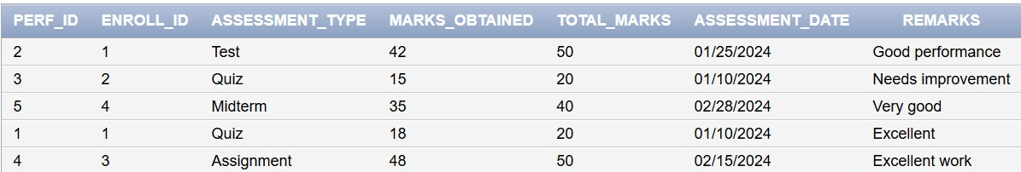

COURSE_PREREQUISITE TABLE
INSERT INTO COURSE_PREREQUISITE (COURSE_CODE, PREREQ_CODE, MIN_GRADE)
VALUES ('MAT201', 'MAT101', 'B');

INSERT INTO COURSE_PREREQUISITE (COURSE_CODE, PREREQ_CODE, MIN_GRADE)
VALUES ('CS101', 'MAT101', 'C');

INSERT INTO COURSE_PREREQUISITE (COURSE_CODE, PREREQ_CODE, MIN_GRADE)
VALUES ('PHY101', 'MAT101', 'C');

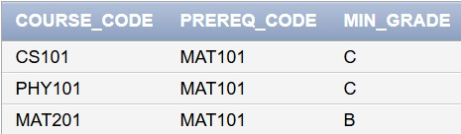

VIEWS CREATION USING SQL

ACTIVE_STUDENTS_SUMMARY VIEW
This view displays each active student's details along with their guardian information, center, batch, and course details.

CREATE OR REPLACE VIEW V_ACTIVE_STUDENTS_SUMMARY AS
SELECT
s.STD_ID,
s.STD_NAME,
s.PHONE,
s.EMAIL,
g.GUARDIAN_NAME,
c.CENTER_NAME,
b.BATCH_CODE,
crs.COURSE_NAME,
e.ENROLL_DATE,
e.STATUS
FROM STUDENT s
JOIN GUARDIAN g ON s.GUARDIAN_ID = g.GUARDIAN_ID
JOIN ENROLLMENT e ON s.STD_ID = e.STD_ID
JOIN BATCH b ON e.BATCH_ID = b.BATCH_ID
JOIN COURSE crs ON b.COURSE_CODE = crs.COURSE_CODE
JOIN CENTER c ON b.CENTER_ID = c.CENTER_ID
WHERE e.STATUS = 'Active';

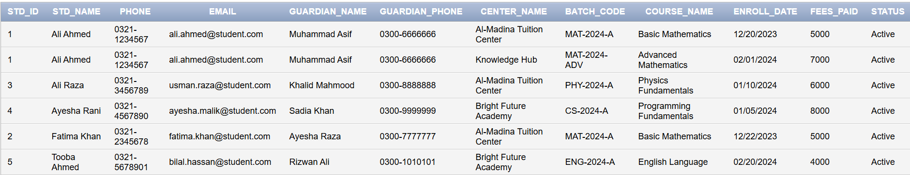

FEE_PAYMENT_REPORT VIEW
The V_FEE_PAYMENT_REPORT view provides fee payment status for all students, including total fee, paid amounts, balances due, and payment statuses.

CREATE OR REPLACE VIEW V_FEE_PAYMENT_REPORT AS
SELECT
s.STD_ID,
s.STD_NAME,
crs.COURSE_NAME,
fs.FEE_AMOUNT AS TOTAL_FEE,
e.FEES_PAID AS PAID_AMOUNT,
(fs.FEE_AMOUNT - e.FEES_PAID) AS BALANCE_DUE,
CASE
WHEN e.FEES_PAID >= fs.FEE_AMOUNT THEN 'Fully Paid'
WHEN e.FEES_PAID > 0 THEN 'Partially Paid'
ELSE 'Not Paid'
END AS PAYMENT_STATUS,
fs.DUE_DATE
FROM STUDENT s
JOIN ENROLLMENT e ON s.STD_ID = e.STD_ID
JOIN BATCH b ON e.BATCH_ID = b.BATCH_ID
JOIN COURSE crs ON b.COURSE_CODE = crs.COURSE_CODE
JOIN FEE_STRUCTURE fs ON crs.COURSE_CODE = fs.COURSE_CODE;

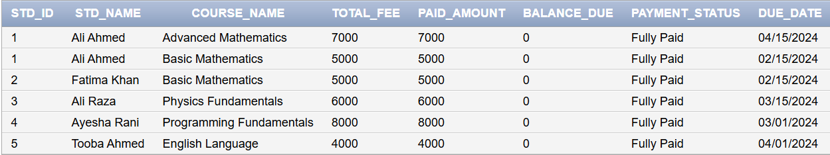

BATCH_SHEDULE _DETAILS VIEW
The V_BATCH_SCHEDULE_DETAILS view provides complete schedule details for all batches, including days, timings, rooms, and tutor information.

CREATE OR REPLACE VIEW V_BATCH_SCHEDULE_DETAILS AS
SELECT
b.BATCH_CODE,
crs.COURSE_NAME,
t.TUTOR_NAME,
c.CENTER_NAME,
bs.DAY_OF_WEEK,
bs.START_TIME,
bs.END_TIME,
bs.ROOM,
b.START_DATE,
b.END_DATE
FROM BATCH b
JOIN COURSE crs ON b.COURSE_CODE = crs.COURSE_CODE
JOIN TUTOR t ON b.TUTOR_ID = t.TUTOR_ID
JOIN CENTER c ON b.CENTER_ID = c.CENTER_ID
JOIN BATCH_SCHEDULE bs ON b.BATCH_ID = bs.BATCH_ID
ORDER BY b.BATCH_CODE, bs.DAY_OF_WEEK;

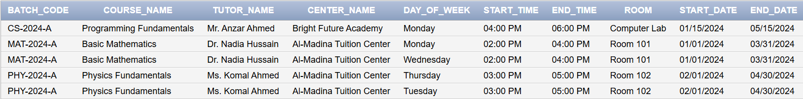

SELECT STATEMENTS FOR COMMON REPORTS

- List all students along with their course, batch, and center details.
SELECT
s.STD_ID,
s.STD_NAME,
s.EMAIL,
crs.COURSE_NAME AS COURSE,
b.BATCH_CODE AS BATCH,
c.CENTER_NAME AS CENTER,
e.ENROLL_DATE,
e.STATUS
FROM STUDENT s
JOIN ENROLLMENT e ON s.STD_ID = e.STD_ID
JOIN BATCH b ON e.BATCH_ID = b.BATCH_ID
JOIN COURSE crs ON b.COURSE_CODE = crs.COURSE_CODE
JOIN CENTER c ON b.CENTER_ID = c.CENTER_ID
ORDER BY s.STD_NAME;

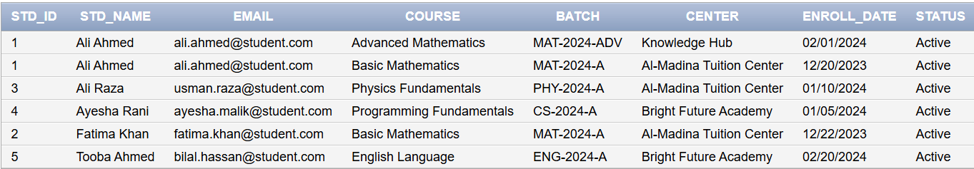

- Get the attendance record of a specific student for a particular course.

SELECT
a.CLASS_DATE,
a.STATUS,
crs.COURSE_NAME,
b.BATCH_CODE,
t.TUTOR_NAME
FROM ATTENDANCE a
JOIN ENROLLMENT e ON a.ENROLL_ID = e.ENROLL_ID
JOIN STUDENT s ON e.STD_ID = s.STD_ID
JOIN BATCH b ON e.BATCH_ID = b.BATCH_ID
JOIN COURSE crs ON b.COURSE_CODE = crs.COURSE_CODE
JOIN TUTOR t ON b.TUTOR_ID = t.TUTOR_ID
WHERE s.STD_ID = 1 AND crs.COURSE_CODE = 'MAT101'
ORDER BY a.CLASS_DATE;

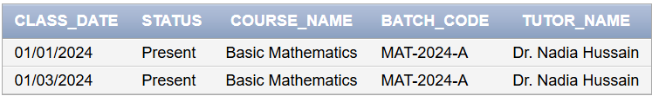
- Find the tutor assigned to each batch with schedule details.

SELECT
t.TUTOR_NAME AS TUTOR,
b.BATCH_CODE AS BATCH,
crs.COURSE_NAME AS COURSE,
bs.DAY_OF_WEEK AS DAY,
bs.START_TIME,
bs.END_TIME,
bs.ROOM,
c.CENTER_NAME AS CENTER
FROM TUTOR t
JOIN BATCH b ON t.TUTOR_ID = b.TUTOR_ID
JOIN COURSE crs ON b.COURSE_CODE = crs.COURSE_CODE
JOIN CENTER c ON b.CENTER_ID = c.CENTER_ID
JOIN BATCH_SCHEDULE bs ON b.BATCH_ID = bs.BATCH_ID
ORDER BY t.TUTOR_NAME, b.BATCH_CODE, bs.DAY_OF_WEEK;

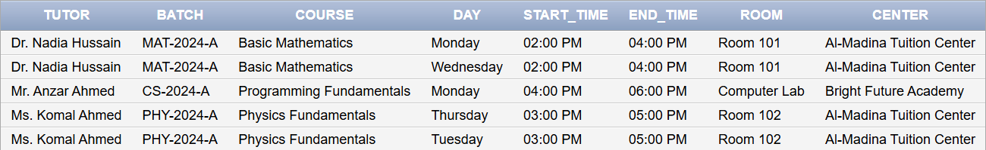

- Retrieve the result/performance of students for a specific course.
SELECT
s.STD_NAME,
p.ASSESSMENT_TYPE,
p.MARKS_OBTAINED,
p.TOTAL_MARKS,
ROUND((p.MARKS_OBTAINED / p.TOTAL_MARKS) * 100, 2) AS PERCENTAGE,
p.ASSESSMENT_DATE,
p.REMARKS,
t.TUTOR_NAME
FROM PERFORMANCE p
JOIN ENROLLMENT e ON p.ENROLL_ID = e.ENROLL_ID
JOIN STUDENT s ON e.STD_ID = s.STD_ID
JOIN BATCH b ON e.BATCH_ID = b.BATCH_ID
JOIN COURSE crs ON b.COURSE_CODE = crs.COURSE_CODE
JOIN TUTOR t ON b.TUTOR_ID = t.TUTOR_ID
WHERE crs.COURSE_CODE = 'MAT101'
ORDER BY PERCENTAGE DESC;

- List all courses along with their fee structure and prerequisites.
SELECT
crs.COURSE_CODE,
crs.COURSE_NAME,
crs.COURSE_LEVEL,
crs.DURATION_MONTHS,
fs.FEE_AMOUNT,
fs.INSTALLMENTS,
fs.DUE_DATE,
prereq.PREREQ_CODE,
prereq_crs.COURSE_NAME AS PREREQUISITE_COURSE,
prereq.MIN_GRADE
FROM COURSE crs
LEFT JOIN FEE_STRUCTURE fs ON crs.COURSE_CODE = fs.COURSE_CODE
LEFT JOIN COURSE_PREREQUISITE prereq ON crs.COURSE_CODE = prereq.COURSE_CODE
LEFT JOIN COURSE prereq_crs ON prereq.PREREQ_CODE = prereq_crs.COURSE_CODE
ORDER BY crs.COURSE_CODE;

